Large Office Shredder 3120S6 – Intelligent Load Control, High Export Volume, Shreds 40 Sheets at Once大型办公碎纸机3120S6——智能负载控制，大量出口，单次40张
Figure 1: Full Machine View
图1：整机图
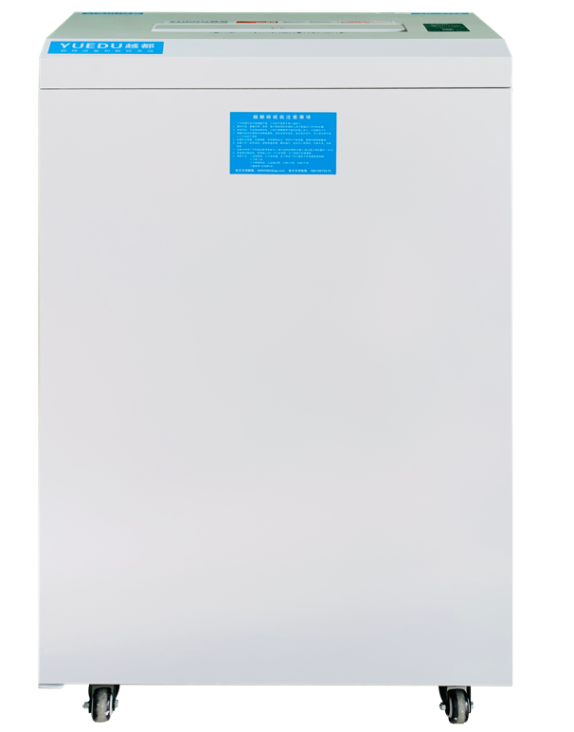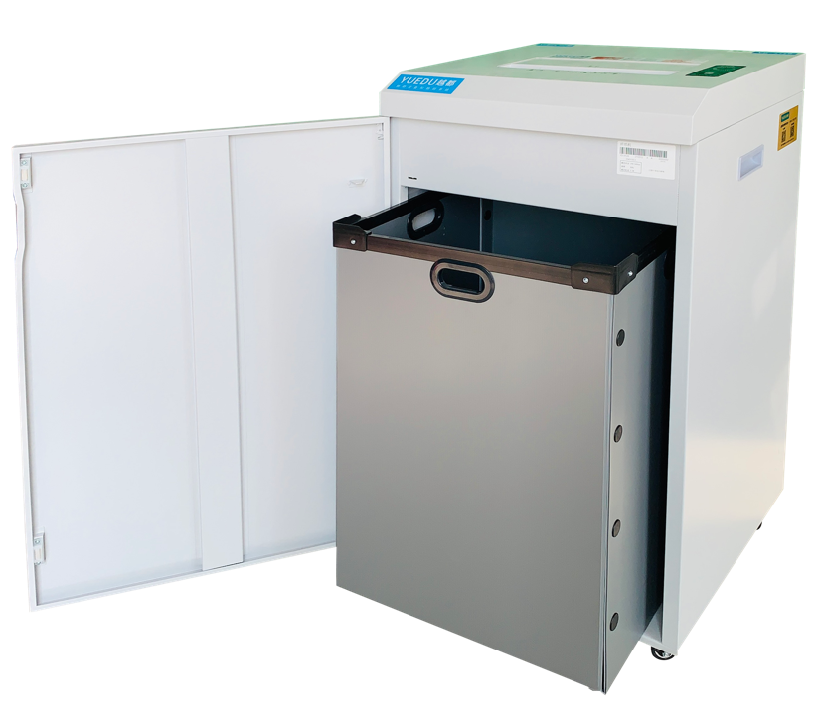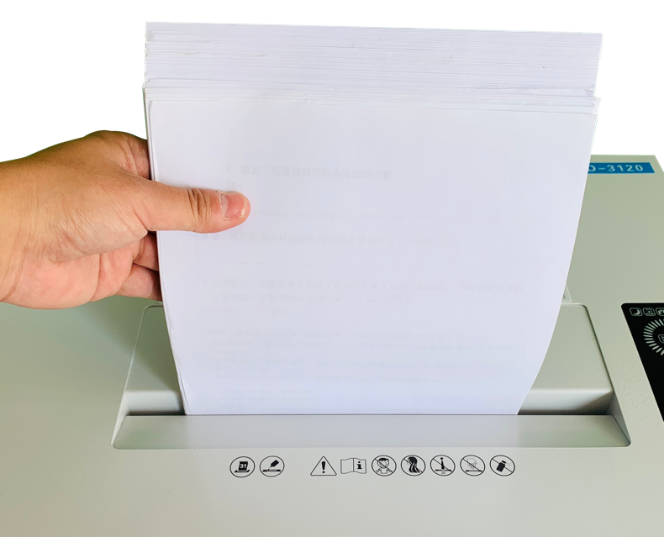
Figure 2: Intelligent Panel, Load Display; Advanced Product Features and Smart Control Functions
图2：智能面板，负载显示；先进的产品特征和智能控制功能
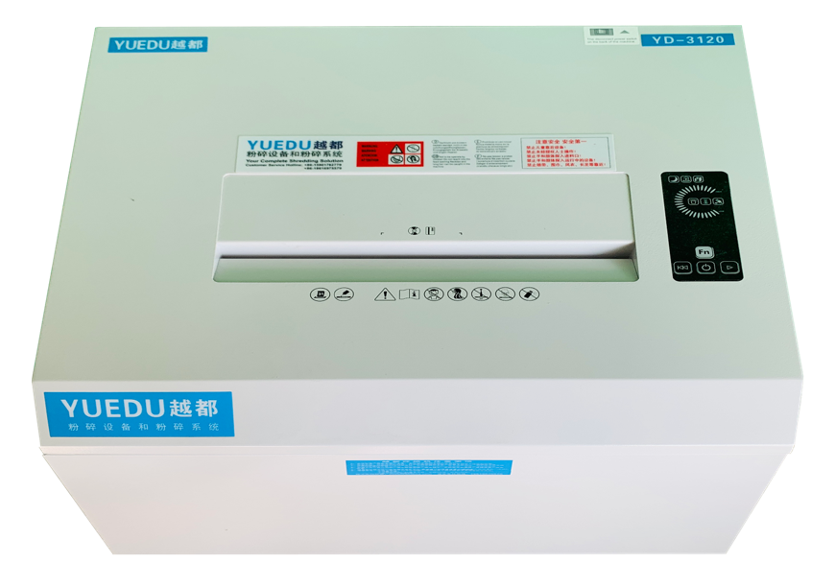 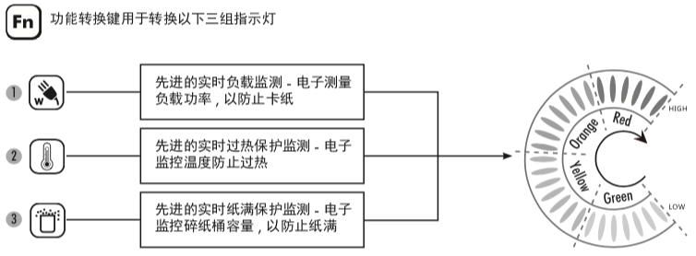
Product Description:
产品介绍：
This ultra-quiet, high-power shredder is designed for secure document destruction and features an intelligent load control panel. It includes separate slots for CDs and credit cards, making it convenient and user-friendly. The machine is capable of continuous operation for 24 hours, shredding A4 paper, magazines, various cards, CDs, paper clips, and staples. It has smart functionalities such as auto-sleep mode, auto-sensing, jam detection, and door open alerts. The shredder can handle up to 32 sheets of A4 paper at once and boasts a high-strength structure with an aesthetically pleasing and premium design. The shredding blades are made from high-quality imported steel, and the high-security series can shred confidential materials into powder, meeting the highest security standards.
超静音大功率涉密材料粉碎机，带智能负载控制面板；机器入口面板自带单独光盘和信用卡入口，方便快捷；可连续24小时不停机工作，粉碎A4纸张，杂志，各类卡和光盘、回形针、订书针。该机不工作时自动休眠，自动感应，卡纸提示，开门提示等智能操作功能。碎纸量最大可以达到32张A4纸，拥有高强度结构，该产品美观高档；碎纸刀为进口材质钢刀；该机有高保密系列将涉密材料粉碎为一级保密标准的粉末状。

Technical Specifications:
• Model: YD-3120 Strip-Cut
• Feed Width: 310mm
• Shredding Output: 5.8mm strips
• Sheet Capacity: 40 sheets
• Shredding Speed: 5 meters/minute
• Continuous Operation: Yes
• Noise Level: 50dB
• Net Weight: 45kg
• Rated Power: 900W
• Dimensions: 532465910mm
• Waste Bin Capacity: 120L
• Product Price: 9991 RMB

技术参数：
型号 | YD-3120条状
进纸宽度 | 310mm
碎纸效果 | 5.8mm条状
碎纸能力（张） | 40张
碎纸速度 | 5米/分钟
连续工作 | 连续
噪音等级 | 50dB
机器净重 | 45kg
额定功率 | 900W
外形尺寸 | 532*465*910mm
废纸箱容量 | 120L
产品价格 | 9991元

Three-view Drawing of YD-3120 Machine
三视图 YD-3120整机
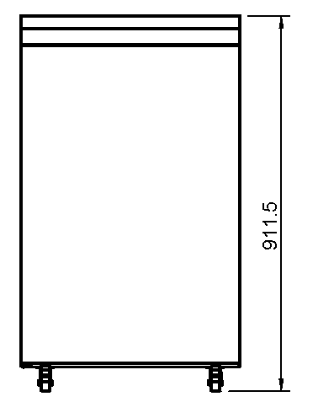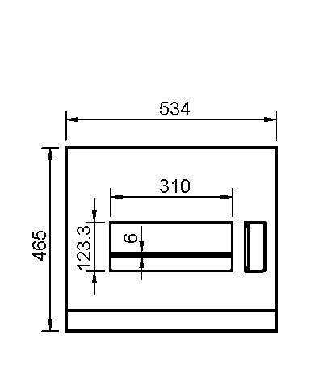
🍭三视图内数字单位毫米（mm）
打包发货
出口发货图
国内发货图
发货前打包
🍀发货默认国内包装；如有出口木箱包装需求，请联系客服核算木箱包装新增费用

整机细节图
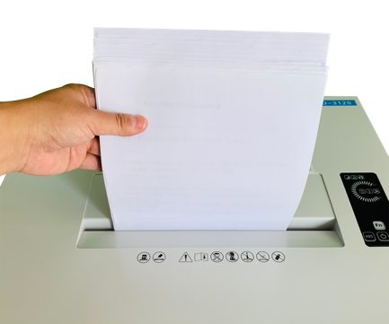 | 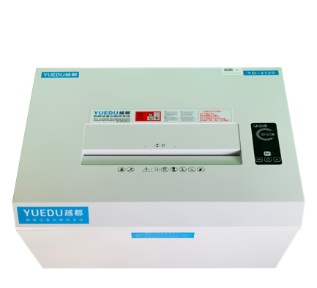 | 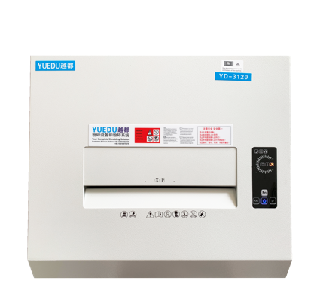
Shredding Entry  粉碎入口 | Device Panel 1  设备面板1 | Device Panel 2  设备面板2
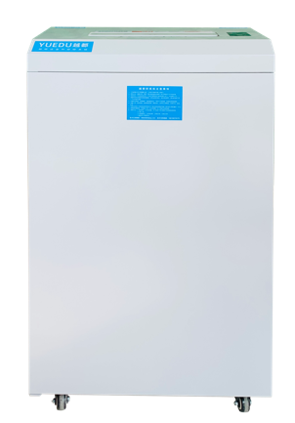 | 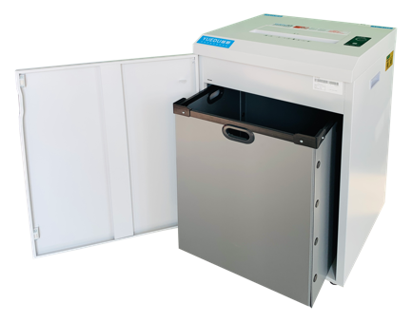 | 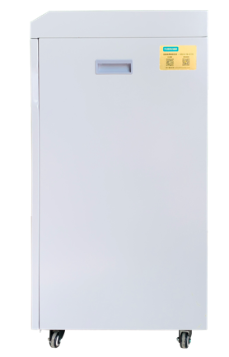
Front View of the Device  设备正面 | Open Door Full View 1  开门整体1 | Right Side of the Machine  机身右侧
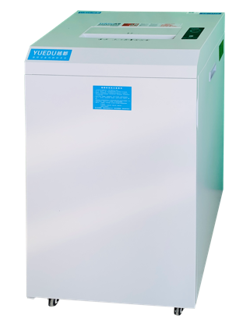 | 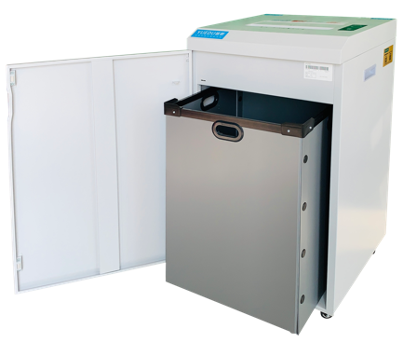 | 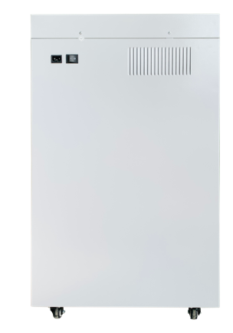
Overall Side View  整机侧面整体 | Open Door Full View 2  开门整体2 | Rear View of the Machine  机器后部

Customer Case - On-Site User:
客户案例-用户现场：

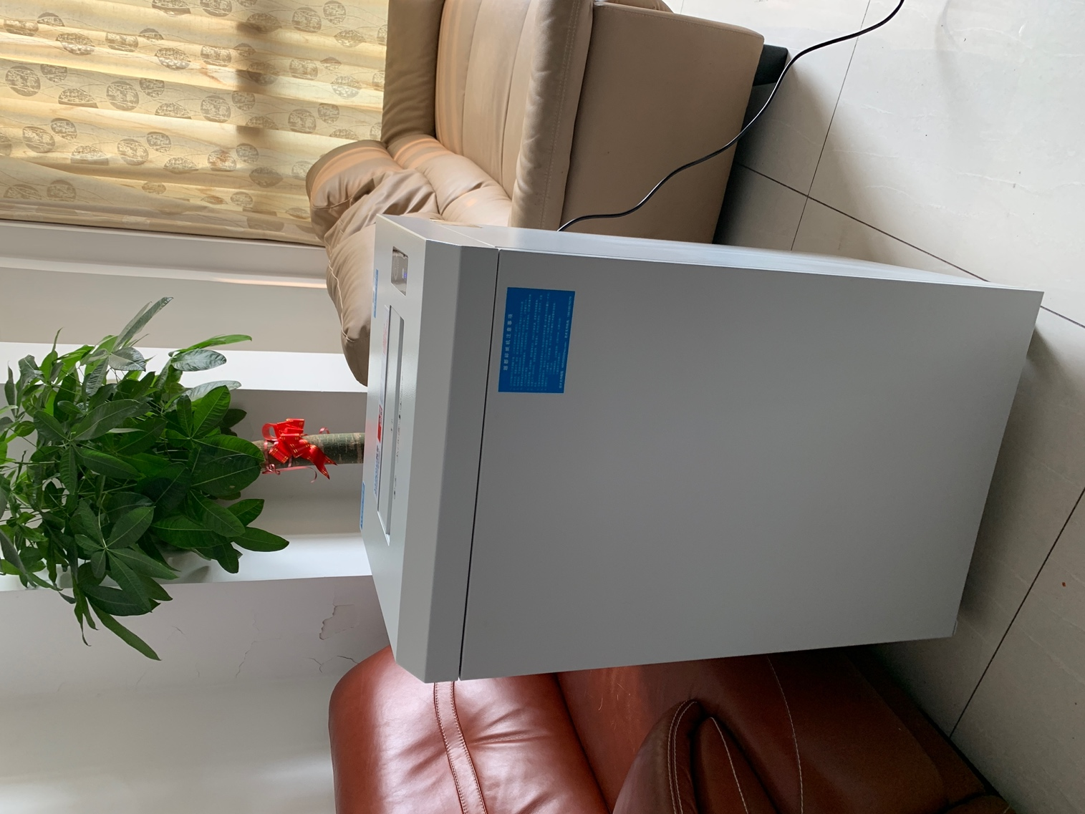 | 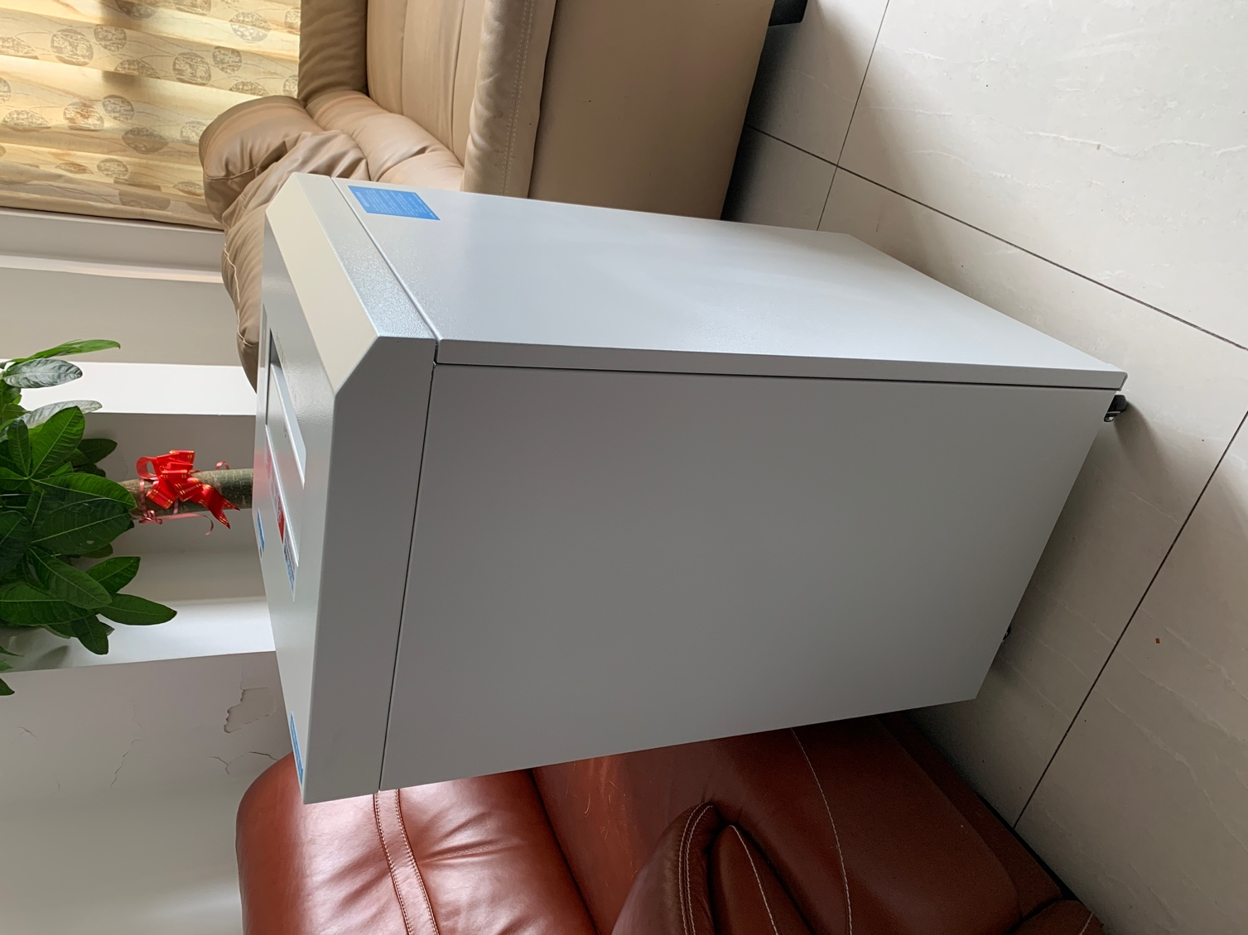
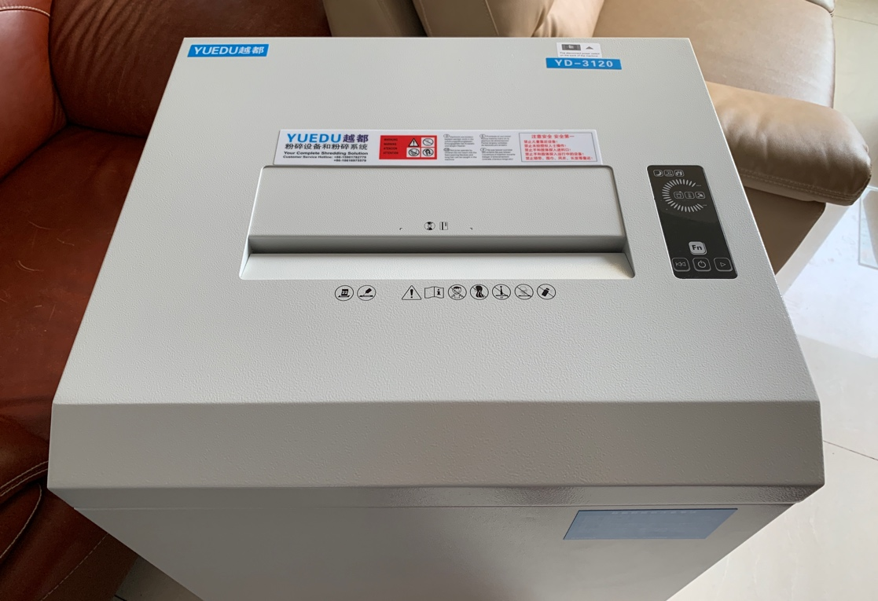 | 